**READING**

1. 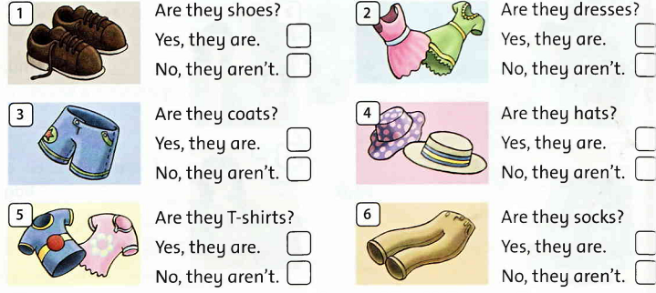**Read and tick the box ( 6ms)**

1. **Read and fill in the correct circle ( 2ms )**

|  |  |
| --- | --- |
| 1. It has three sides. What is it? 2. It’s a square. 3. It’s a triangle. 4. It’s a circle. | **E:\TÀI LIỆU ANH VĂN\BINH LOI TRUNG\ĐỀ THI\2017 - 2018\lop 2\hk2\pic\images (10).jpg**  3. They’re big. What are they? (A) They’re monkeys. (B) They’re elephants. (C) They’re tigers. |
| 2. It doesn’t have sides. What is it? ( A ) It’s a square. ( B ) It’s a triangle. ( c ) It’s a circle. | **E:\TÀI LIỆU ANH VĂN\BINH LOI TRUNG\ĐỀ THI\2017 - 2018\lop 2\hk2\pic\download (5).jpg**  4. They’re little. What are they? (A) They’re lions. (B) They’re elephants. (C) They’re monkeys. |

**III. Read, write and match**

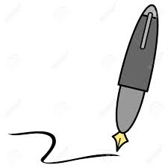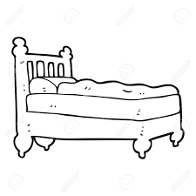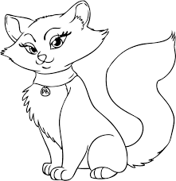

f……n

b……d

c……t

p……n

**WRITING**

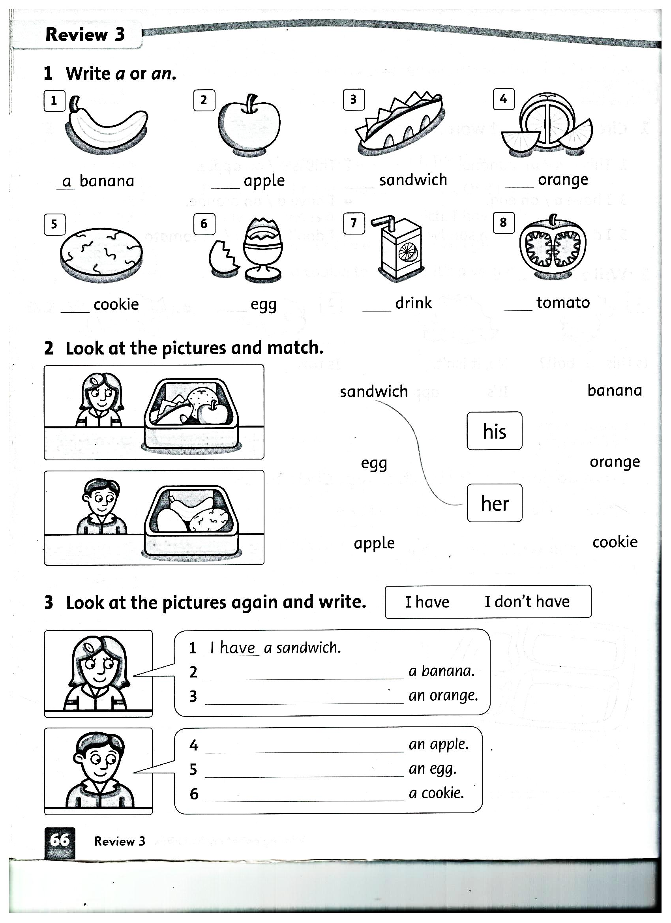**I. Look at the picture. Write “a” or “an”. (6 ms)**



like don’t like

**II. Write and match (2ms)**

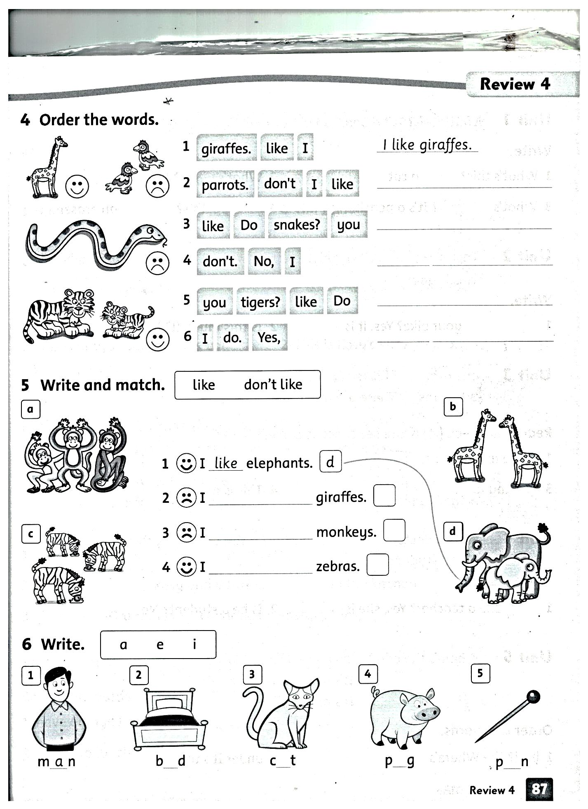

I __________elephants

